**VBA HW: Multiple_year_stock_data_CD Screenshots**

**Year 2016 (More details can be found in “Multiple_year_stock_data_CD”) spreadsheet**

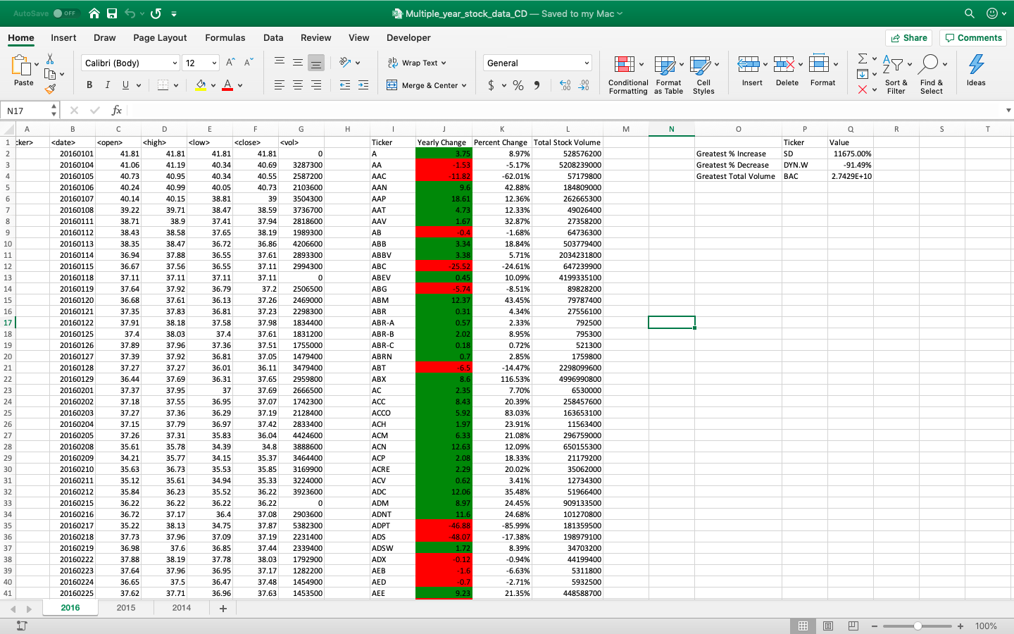

**Year 2015 (More details can be found in “Multiple_year_stock_data_CD”) spreadsheet**

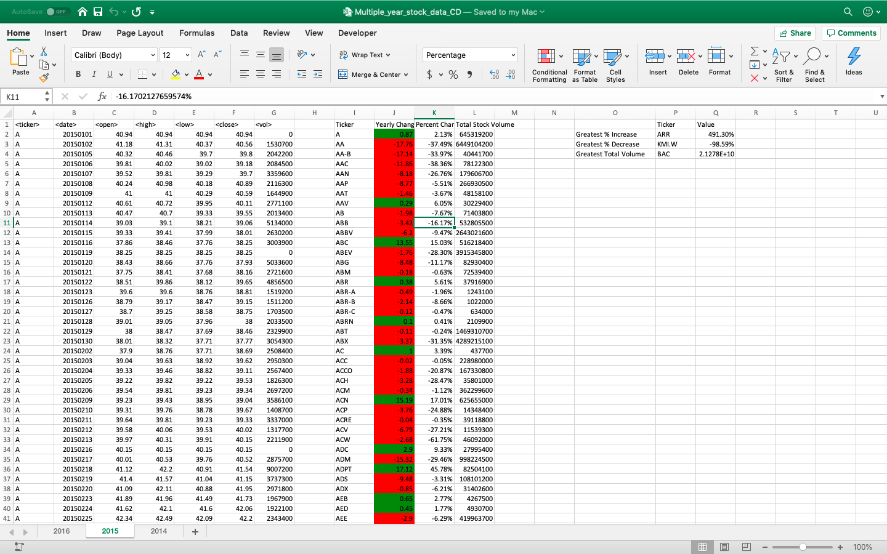

**Year 2014 (More details can be found in “Multiple_year_stock_data_CD”) spreadsheet**

